Database ERD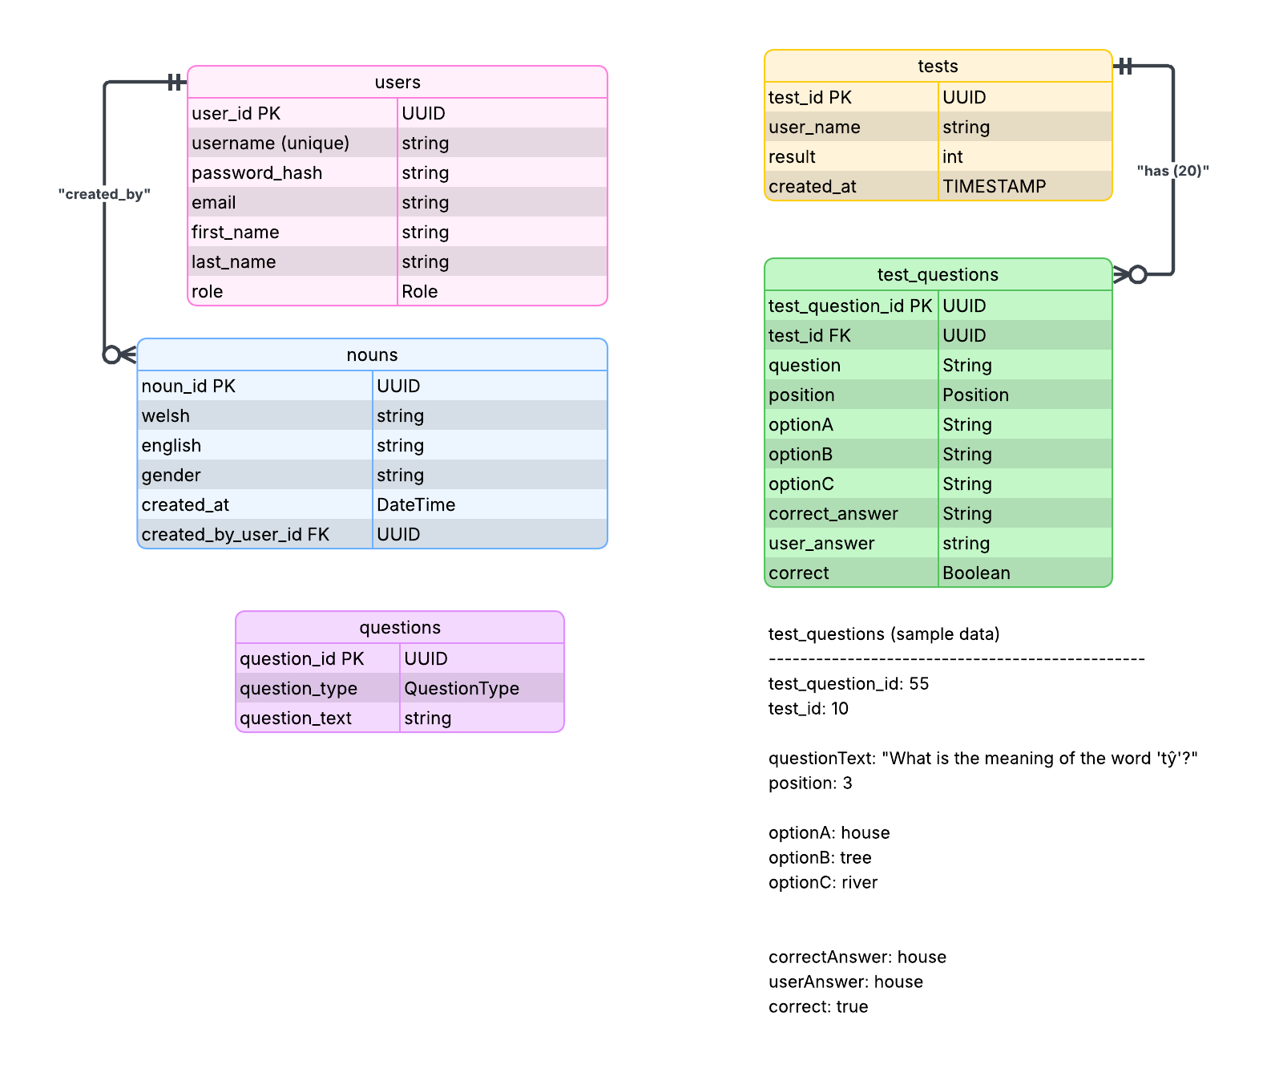

Inside the program, we would call the method to getNoun() from the Noun class (selecting a random noun) something like ...

new Noun N = N.getNoun()

and then use getQuestion() in the question class to create a question instance randomly from the three choices.

new Question Q = Q.getQuestion()

inside this after choosing a question from the three options a question builder method builds the string using whatever data from the noun class we needed (this will be coded in the class, like we need gender and welshnoun for a gender question etc...) like,

//get answer
if Q.type() == "Meaning"
answer = N.getEnglishNoun()

//get noun for question string
QuestionText = "What is the meaning of the word <n.getWelshNoun()>"

It then calls a method to get incorrect answers for the multiple choice, getting the englishNoun from other random fields in the database (checking they're not the same as each other or the correct answer) they're added to a list with the correct answer
20 questions are made the same way and added to a list.

all that can be sent the UI constructor whatever that looks like
The questions can randomly be assigned positions 1-20 which we store
the answer options can be randomly selected from the list to populate the UI placeholders answer a, b, c ..etc which we also store
Once a user has completed the test we can use the stored data as well as getting session data from the DOM (is it called that in java) for like answers they chose...that can be added with username, score and date, ...to a new objects in the Test and TestQuestions classes which are the database entity model and that automatically adds to the DB frields (right?)

QuestionText (the full question string) will be sent to the TestQuestion table
The answers will be stored as strings in the options A-C (or however many options there'll be)
all sent as strings from in the program not joined by fks to nouns or questions stored in the db.

